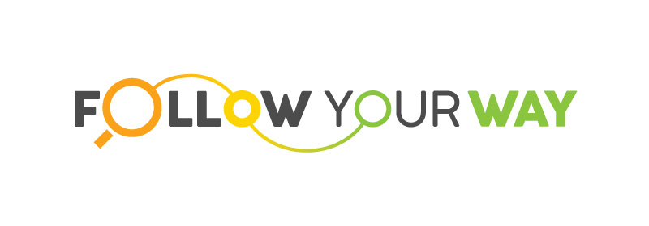 PROJECT MANAGEMENT Meeting
PROJECT NUMBER: 2017-3-CZ01-KA205-046864
Dates: 02/06 – 04/06 2018
Location: Prague
PRESENT:
International Educational Center GEMS | Alena Jeslinkova, Andrea Csirke, Alice Mullerová
Klaipėda Pedagogical Psychological Service | LoretaStaskuniene, Kristina Gelazauskiene
Travelogue | Silvia Bonomi, Tatiana Catallo
TheDojo.Org.UK | Francis Nwofor, Hollie Nwofor

This meeting was the first with had a threefold objective:
- 1stly a meet and greet for all the partners participating in the project,
- 2ndly to explore the project theme in more details and agree on definitions as well as meaning of statement in the application document with the view to clarification,
- 3rdly, task allocation based on partners’ skill set and knowledge domain
The meeting kicked off with each partner presenting both themselves and their organisation, mainly information dissemination, their mission, ethos, aims, objectives and track record of achievements.
The crust of the meeting came as we looked to explore the project theme in more details, this proved to be challenging, owing to the fact that each person had a varying definition and understanding of certain key words in the project description, thus creating a flux of differing expectations for project. As the discussion progressed and various working definitions reached, we arrived at our goal, which was to have a single, clear and unified understanding of the project aims, objectives and expected outcomes.
The meeting concluded with each partners agreeing to actioned to take the lead on various key tasks; thus, a gantt chart/project timeline has been created and sent to each partner.

